Albert Cairo gives a 5 point framework to estimate the quality of a given Data Graphic. Note that he also mentions that the 5 frameworks or quality checks are not independent but interrelated.

**Truthfullness**

The first and the most important thing for any data graphic is it being truthful. Under this Cairo talks about the fact that when we are cleaning, summarizing and manipulating the data we should ensure that, we are not,

1. Misleading Ourselves(Self Deception)
2. Misleading our Audience

This general has large impacts and leads to a sense of distrust among the people involved.

Note that truth itself is not the truth but is a relative quantity. Some data visualizations can be more deceptive/truthful to the others. See example below to understand.

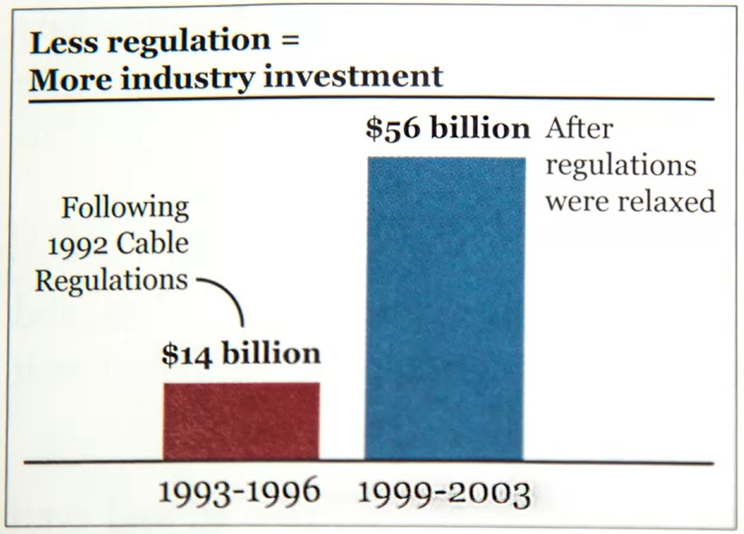

Now lets see the graph. There are two errors that we can easily point out.

1. The data might not be adjusted as per inflation.
2. The time period employed in either case is different, giving it more weight than it actually has on paper.

Lets see another Graph related to this data.

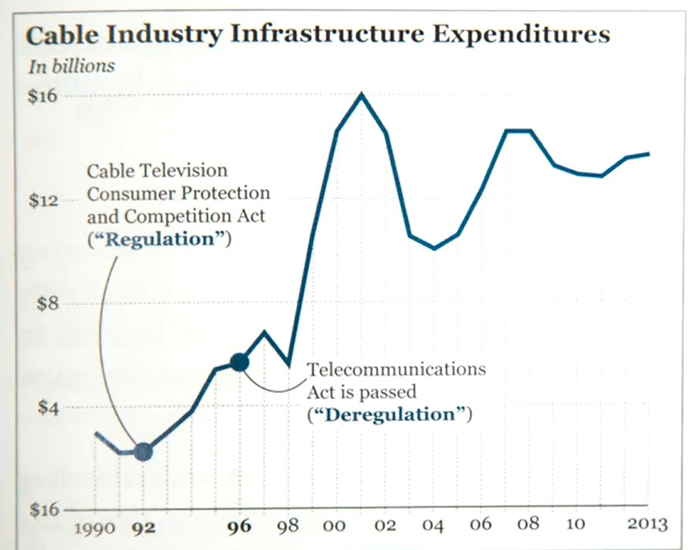

Now see this graph. The first graph paints the narrative of how deregularization made increased the investment in the sector. While the second plot clearly show sudden dip in a continuously increasing trend post deregularization followed by various ups and downs, discounting various external reasons.

So the 2nd graph is more truthful than the first, but does not represent the absolute truth.

**Functionality**

The functionality of a given Data Graphic can be simply find out via the fact whether the intended audience of the Graphics In consideration is able to take out the necessary inferences that we want them to take out.

Now there can we various ways of ensuring that. One could be ensuring that out data has the high ink ratio. Its always easier for audiences to take out inferences from such type of graphs. Example is as follow,

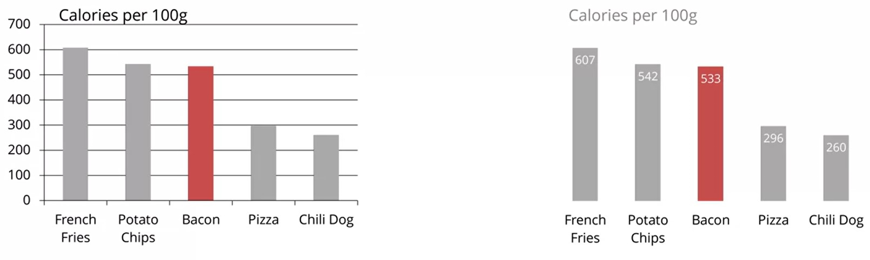

The right one is the one with high ink ratio and also has the higher functionality.

Another way of testing functionality of our Graphics is via conducting research/poles etc with help of crowd who could use our models. Example of this is observable in case of

“High Ink Ratio v/s Duck Graphs”